**SECTION A (40 MARKS)**

1. Give one health habit one should practice to avoid food contamination.

_____________________________________________________________________

2. Which body organ does Hepatistis affect?

_____________________________________________________________________

3. Give any one example of a fossil fuel.

_____________________________________________________________________

4. Besides being vertebrate, how else are birds similar to mammals?

_____________________________________________________________________

5. Why is it necessary to drain stagnant water around a home?

_____________________________________________________________________

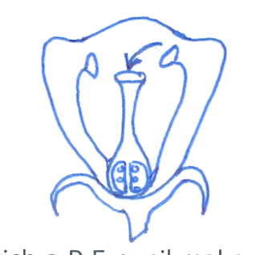6. On the diagram below, label with letter x the part that produces pollen grains.

7. Apart from capital, give one other requirement for starting a livestock farm?

_____________________________________________________________________

8. Identify one accident that requires the use of splints in giving firstaid.

_____________________________________________________________________

9. Give one exotic breed of goat reared for milk production.

_____________________________________________________________________

10. Name the energy resource obtained from animal dung and urine.

_____________________________________________________________________

11. State one way of reducing echoes in a hall.

_____________________________________________________________________

12. Give one reason why we use toothpaste for brushing teeth.

_____________________________________________________________________

13. The diagram below shows a horse shoe magnet. Identify pole marked P.

_____________________________________________________________________

14. Give one disadvantage of free range system of poultry.

_____________________________________________________________________

15. Identify one condition in babies that causes drylips and a sunken soft spot on the head.

_____________________________________________________________________

16. Why are animals grouped under renewable resources?

_____________________________________________________________________

17. Which mineral salt is necessary for the formation of red blood cells in people?

_____________________________________________________________________

18. Apart from melting, state any one other physical change that takes place in the presence of

heat.

_____________________________________________________________________

19. Name the disease that affect both rabbits and poultry.

_____________________________________________________________________

20. Why does oil settle on top when mixed with water?

_____________________________________________________________________

21. Give one example of wading bird.

_____________________________________________________________________

22. In which method of making water clean do you first allow the impurities to settle at the

bottom of the container?

_____________________________________________________________________

23. State the piece of advice given to a person who suffers constipation.

_____________________________________________________________________

24. Why is maize grouped under monocotyledonous plants?

_____________________________________________________________________

25. How is the function of the pulmonary artery different from that of other arteries?

_____________________________________________________________________

_____________________________________________________________________

26. Which property of air enables you to drink soda using a straw?

_____________________________________________________________________

27. What name is given to disease caused due to lack of a certain food value in one’s diet?

_____________________________________________________________________

28. State one way in which married couples can avoid HIV/AIDS among themselves.

_____________________________________________________________________

29. In which way is the use of solar energy good to our environment?

_____________________________________________________________________

30. Which body system help to remove harmful waste products produced by the body cells?

_____________________________________________________________________

31. In which way can a donkey be used as an energy resource?

_____________________________________________________________________

32. What is a joint?

_____________________________________________________________________

_____________________________________________________________________

33. Mention one PIASCY message.

_____________________________________________________________________

34. Why is a pregnant woman said to be a vulnerable person?

_____________________________________________________________________

35. Which element of PHC promotes quick recovery?

_____________________________________________________________________

36. Describe one importance of a school health parade.

_____________________________________________________________________

37. Which component of soil is needed by plants to make food?

_____________________________________________________________________

38. State one similarity between a housefly and a fresh water snail.

_____________________________________________________________________

39. Which force enables us to walk?

_____________________________________________________________________

40. Give one secondary sex characteristic in boys.

_____________________________________________________________________

**SECTION B (60 MARKS)**

41. a) Which term refers to a sudden happening that results into injury or death?

_____________________________________________________________________

b) Give two examples of (a) above.

i) _________________________________ ii) _____________________________

c) State any one quality of a good firstaider.

_____________________________________________________________________

42. a) Name one exotic breed of cattle purposely reared for;

i) beef production ____________________________________________________

ii) milk production _____________________________________________________

b) State one way you can identify a beef breed from a dairy breed.

_____________________________________________________________________

c) Apart from beef and milk production, how else are cattle useful to people?

_____________________________________________________________________

43. a) What is seed dispesal?

____________________________________________________________________

_____________________________________________________________________

b) Name any two agents of seed dispersal.

i) _________________________________ ii) _____________________________

c) State one advantage of seed dispersal in the environment.

_____________________________________________________________________

44. The table below shows joint and their position in the human body. Study it and complete it

correctly.

**Joint Position in the body**

Pivot joint ________________________

______________________ shoulder

______________________ knee

Suture joint _______________________

45. a) Primary Five pupils were given two objects i.e an apple and a brick. Which method

would the pupils apply to find the volume of each.

1. an apple __________________________________________________________
2. a brick ___________________________________________________________

b) Name any equipment the pupils needed to have to find the volume of an apple.

_____________________________________________________________________

c) If the brick had a mass of 120gm and a density of 5gm/cc, what volume did they pupils

get?

## 

_____________________________________________________________________

46. The diagram below shows the alimentary canal of man. Study it carefully and answer

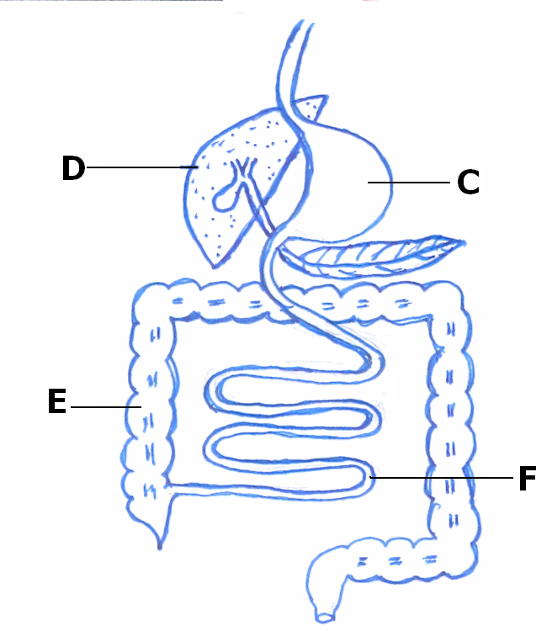questions that follow.

B

a) Name the parts labelled D and F.

i) D _____________________________ ii) F ___________________________

b) Mention the digestive juice produced by B.

____________________________________________________________________

c) Why does digestion of food end in part F?

____________________________________________________________________

47. a) State any two differences between a housefly and a spider.

i) ________________________________________________________________

ii) ________________________________________________________________

b) Give one similarity between a housefly and a spider.

_____________________________________________________________________

c) Mention one disease spread by a housefly in people.

_____________________________________________________________________

48. a) Blood is a liquid tissue found in the body of most animals. Name any one component of

blood.

_____________________________________________________________________

1. Give at least two functions of blood in the human body.

i) ________________________________________________________________

ii) ________________________________________________________________

c) In the space below, draw and name the shape of any blood cell.

49. a) Write STD in full.

_____________________________________________________________________

b) Give any one example of STDs caused by bacteria.

_____________________________________________________________________

c) Suggest any two dangers of premarital sex.

i) ________________________________________________________________

ii) ________________________________________________________________

50. a) State one danger of taking drugs without a medical workers instructional.

_____________________________________________________________________

b) Mention any two useful pieces of information written by a medical worker on a

prescription sheet given to a patient.

i) _________________________________ ii) _____________________________

c) Give any one reason why people take medical drugs.

_____________________________________________________________________

51. a) Give one way in which Primary Health Care(PHC) is a promoted in a family.

_____________________________________________________________________

b) State one way PHC is promoted by each of the following;

i) individuals ________________________________________________________

ii) community ________________________________________________________

c) Mention one role of a school health committee.

_____________________________________________________________________

52. a) What type of change takes place when a knife rust?

_____________________________________________________________________

b) Give two conditions necessary for rusting to take place in a knife.

i) _________________________________ ii) _____________________________

c) State any one effect of rusting on a knife.

_____________________________________________________________________

53. Match the source of energy to the type of electricity produced.

**Source Type of electricity**

flowing water solar electricity

hot springs thermal electricity

burning of coal hydro electricity

the sun for thermal electricity

i) flowing water __________________________________________________

ii) hot springs __________________________________________________

iii) burning of coal __________________________________________________

iv) the sun __________________________________________________

54. a) What is sound? ____________________________________________________

_____________________________________________________________________

b) John was hitting a drum 10m away from where Tom was sitting. How was Tom able to

hear the sound of the drum?

_____________________________________________________________________

c) How does a drum produce sound?

_____________________________________________________________________

d) Give any one natural source of sound.

_____________________________________________________________________

55. Name one example of a disease people are likely to get under the following condition.

i) poor disposal of faeces _______________________________________________

ii) poor feeding ______________________________________________________

1. having unprotected sex ______________________________________________
2. poor personal hygiene _______________________________________________

***Good luck!***